
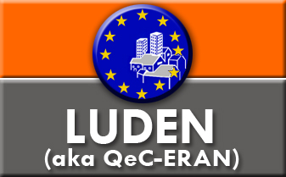

Multi-Cultural Europe: The Challenge of Integration

June 17 and 18 2011

Modena City Hall

The issue of integration has once again become a “hot” issue. Governments in the UK, Germany, Holland, France and Belgium have over the past year announced that “Multi-culturalism has failed”. Alongside this, there has been a growing backlash against immigration as evidenced by the increasing success of far right parties both at national and European levels. The backlash is not just directed at “foreigners”. EU citizens such as Roma have faced violent reactions to their presence across Europe.
At the same time structural demographic change in the EU means that more immigration is essential in order to meet the economic goals of the EU 2020 strategy.

Our event seeks to highlight the reality of integration at an EU and local level. On day one there will be inputs that address the EU integration agenda and actions that are being taken at local level in Modena (IT), Charleroi (BE) and Amadora (PT). These will be followed by study visits to projects on the ground in Modena.

Day two will be one of “political” debate. Has Multi-Culturalism failed? We will have panel of politicians from Italy and Belgium alongside activists and academics working in this field.

A copy of the programme is available here

Participation is Free BUT registration is compulsory. To do so please send an email with the subject heading LUDEN Study workshop to c.torchiaro@ludenet.org

Working languages will be English, Italian and French;

